*Heaven’s light is our guide.*

****Rajshahi University of Engineering and Technology**

**

**Department of Electrical & Electronic Engineering**

**Course no.** EEE3100

**Course title:** Electronic Shop Practice

**Project name:** Smart home automation system using Arduino

**Date of experiment:**  , 2022.

**Date of submission:** August 12, 2022.

|  |  |
| --- | --- |
| **Submitted to:** | **Submitted by:** |
| **Sunjidah Hossain**  **Lecturer**  Dept. of Electrical & Electronic Engineering,  Rajshahi University of Engineering and Technology. | **Group: 09**  **Roll:**  1801169, 1801170, 1801171, 1801172, 1801173, 1801174  **Session:** 2018-2019  Dept. of Electrical & Electronic Engineering,  Rajshahi University of Engineering and Technology. |

**Project Name**

Smart home automation system using Arduino

**Motivation**

Electrical energy is the basic necessity for the economic development of a country. It is practically impossible to estimate the actual magnitude of the part that energy has played in the building up of present-day civilization. The availability of huge amount of energy in the modern times has resulted in a shorter working day, higher agricultural and industrial production and better transportation facilities. The greater the per capita consumption of energy in a country, the higher is the standard of living of its people.

But nowadays we are facing the crisis of electricity. It is not only national but also has become an international crisis. There are many reasons behind this. But we must have to find a solution to overcome this. One step that we can take to save the electric power is stopping the unnecessary use of it. Through the implementation of our project, we can save electric power and overcome the present crisis.

**Theory**

Smart home automation refers to the system where good internet connection is available and the devices of the home can be controlled using various digital applications or other tools. In this project we are going to control the switch of the LED bulbs using Arduino and other components. A Bluetooth apk is used to control the switches after pairing the particular device with the Arduino controller device. The controlling range of the system is around 10 meters. That means any person can on or off the bulbs of his/her home using phone from out of the room around 10 meters. If anyone forget to turn off any electronic devices, he can do it after leaving the place when he remembers. Using this concept, we can save a large amount of electric power.

**Required Apparatus**

1. Arduino
2. Dual channel relay
3. Bluetooth module (HC-05)
4. Laptop
5. Phone
6. LED Bulb (2 pieces)
7. Connecting wires

**Circuit Diagram:**

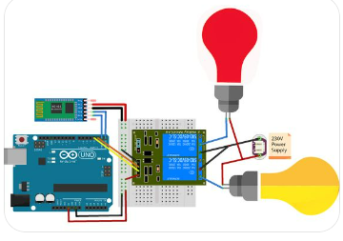

Fig.01: Smart home automation system using Arduino

**Projects Diagrams:**

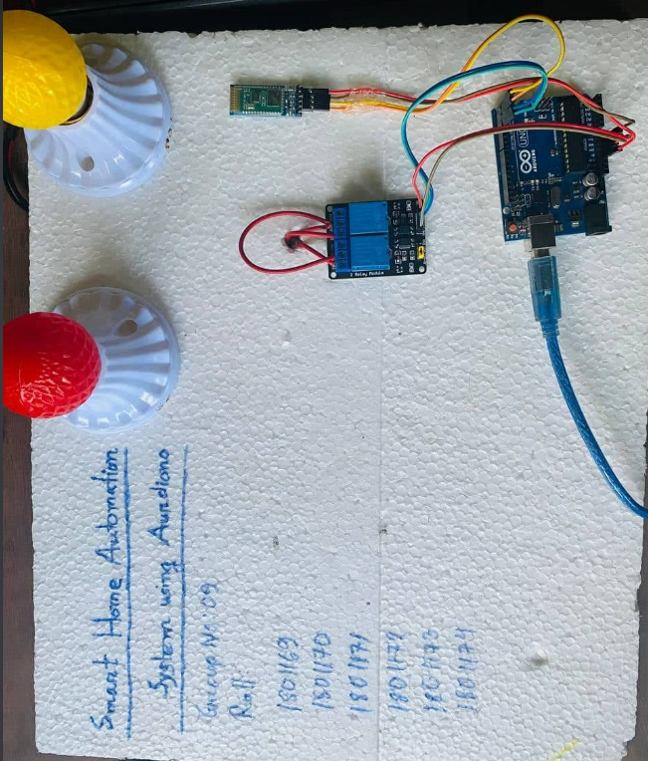

Fig.02: Smart home automation system full project view

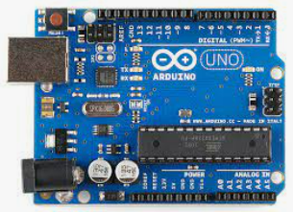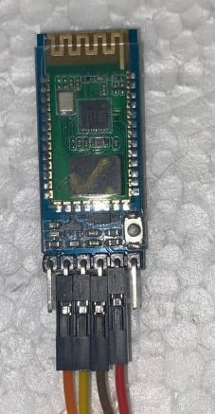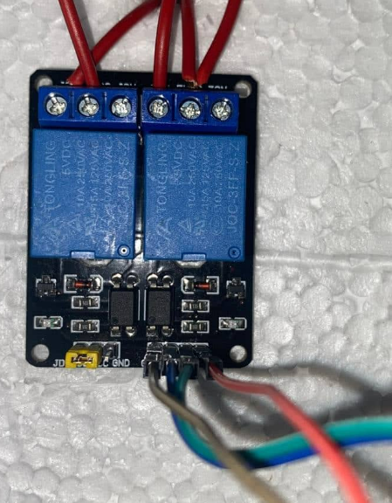

Fig.03: Components of the project (Arduino, Relay, Bluetooth Module)

**Procedure:**

* At first the components were connected with each other according to the circuit diagram
* For controlling the Arduino, a software was downloaded and a code was built up including the commands
* 5v supply voltage was given to the dual channel relay separately as the relay does not work below 5v
* The pin of 3.3v of the Arduino was connected to the Bluetooth module
* Two LED bulbs were connected of red and yellow color
* A Bluetooth apk was downloaded in the phone and it was paired with the Arduino controller device
* Six commands were added in the code (all on, all out, red bulb on, red bulb off, yellow bulb on, yellow bulb off)
* Then the project was tested using voice command through the phone that was paired with the Arduino controller device
* The bulbs were turned on and off according to the commands and the range of the Bluetooth controlling was checked and it was approximately 10 meters

**Code for Arduino:**

**#define yellow 2**

**#define red 3**

**void setup() {**

**// put your setup code here, to run once:**

**Serial.begin(9600);**

**pinMode(yellow, OUTPUT);**

**pinMode(red, OUTPUT);**

**}**

**void loop() {**

**// put your main code here, to run repeatedly:**

**if(Serial.available() == 1)**

**{**

**String val = Serial.readString();**

**Serial.println(val);**

**if(val == "yellow bulb on")**

**{**

**digitalWrite(yellow, HIGH);**

**}**

**if(val == "yellow bulb off")**

**{**

**digitalWrite(yellow, LOW);**

**}**

**if(val == "red bulb on")**

**{**

**digitalWrite(red, HIGH);**

**}**

**if(val == "red bulb off")**

**{**

**digitalWrite(red, LOW);**

**}**

**if(val == "all on")**

**{**

**digitalWrite(yellow, HIGH);**

**digitalWrite(red, HIGH);**

**}**

**if(val == "all out")**

**{**

**digitalWrite(red, LOW);**

**digitalWrite(yellow, LOW);**

**}**

**}**

**}**

**Write to**

**Applications:**

As the main motive of this project is to save the electric power so we can apply it in almost everywhere. Because we know that nowadays we can rarely find any place where is no use of electricity. Though the name of the project is given smart home automation it is not compulsory to apply it only in home, it can be applied or used in offices, schools, colleges, universities, industries and so on.

Though in this project only bulbs were controlled using the system we can also control other devices as well like fan, motor, television, air conditioner etc.

**Advantages:**

* Electric power can be saved
* It saves time and energy
* Simple to operate
* Cost is not so more
* Crisis of electricity can be overcome

**Discussion & Conclusion**

The main purpose of these project was to develop a smart & innovative system that saves power and create a user-friendly control system. This project can be upgraded to better and wider usage version by initializing Iot with the system. Unfortunately, due to some restriction and limitation, this was not possible. Apart from that, the project was a success.